CLIENT TRAINING
How to ApproachYour Sales Call
Why the way you open the call determines everything that comes after it.

Most loan officers show up to a paid lead call the same way they’d show up to a referral. Same energy. Same opener. Same process. And they wonder why it’s not working.
This training exists to fix that. By the end of it, you’ll understand exactly why your approach has to be different with online leads — and more importantly, how to show up in a way that builds trust fast, removes resistance, and positions you as the expert in the room.
🗺️ What This Training Covers
Section 1 — The Two Types of Leads and Why They Require a Different Approach
Section 2 — The Real Problem: Congruency Between Marketing and Sales
Section 3 — Your Identity on the Call: Retirement Expert vs. Reverse Expert
Section 4 — Your Fiduciary Responsibility as the Professional in the Room
Section 5 — How to Open the Call the Right Way

SECTION 1
The Two Types of Leads
Not all leads are the same. Before you pick up the phone, you need to understand who you’re actually calling — because the mindset of that person on the other end of the line determines everything about how you should show up.
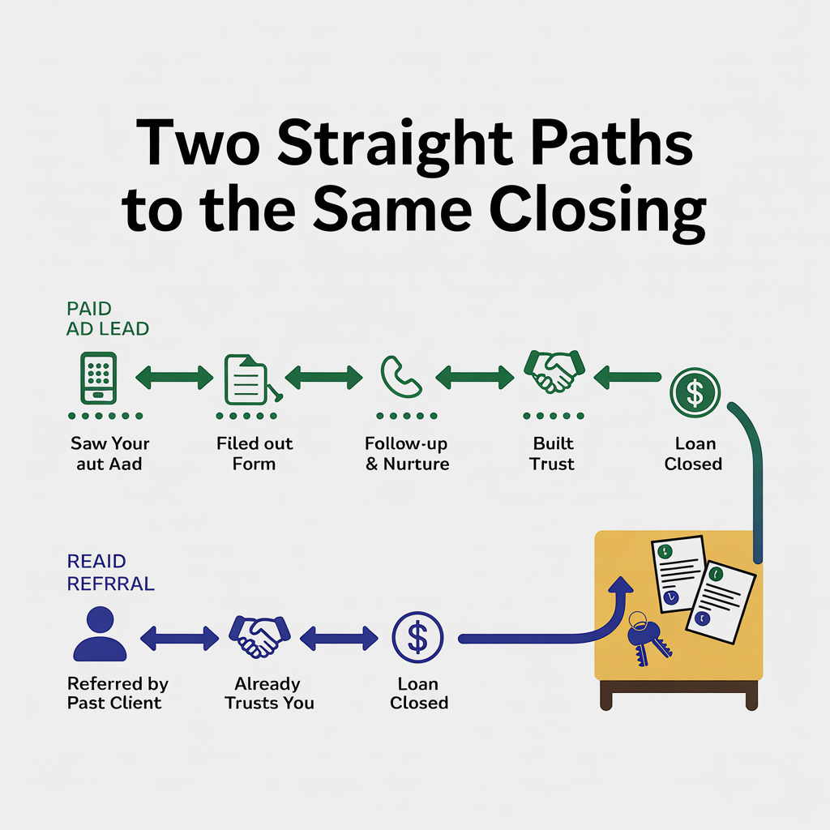
Referral Leads (Warm)
A referral lead comes to you pre-loaded with trust. Someone they know — a financial advisor, a past client, a family member — has already vouched for you. They’ve likely had a real conversation about reverse mortgages before they ever spoke to you. They may even be sold on the concept and are simply looking to confirm you’re the right person to execute it.

With referral leads, trust is partially pre-built. Your job is to confirm fit, structure the deal correctly, and move forward. You can be direct. They’re ready.

Online Leads
An online lead is a completely different person. They saw an ad — your ad — that resonated with a problem they were already carrying around. They clicked, answered a set of qualifying questions, and submitted their information. That’s real intent. But here’s what you have to understand:

- They have no relationship with you
- They may have heard negative things about reverse mortgages
- They don’t fully understand the product or how it could solve their problem
- They are skeptical by default — because they’ve been marketed to their whole lives

This is not a warmed-up referral. This is someone who clicked on an ad. The trust that a referral brings automatically? You have to earn it, on the call, in real time.

Side-by-Side: The Core Differences

Referral Lead | Online (Paid) Lead
Pre-loaded with trust from someone they know | No prior relationship — trust must be built from scratch
Often educated on reverse mortgages before the call | May be skeptical or misinformed about the product
Ready to confirm and move forward | Needs to be educated and guided
You can be direct and process-focused | You must lead with curiosity and genuine care
Lower resistance on the call | Objections form early if you approach it wrong

💡 The Key Insight
The referral approach works because trust is already there. When you take that same approach with a cold lead, you skip the trust-building that makes everything else possible. That’s where most loan officers lose the deal — not in the close, but in the first 90 seconds.

SECTION 2
The Congruency Problem
Here’s something most loan officers never think about: there has to be a direct line between how we market to your leads and how you show up on the call.

Our ads are educational. We’re not running “Call now for a free quote” stock image ads. We’re running content that teaches homeowners something, challenges a belief they have, or addresses a financial pain they’re living with. By the time they submit their information, they’ve already been positioned to see you as a credible resource — not a salesperson.

If you get on the phone and immediately launch into rates, eligibility, and product features, you break that positioning instantly. You become the thing they were trying to avoid.

What Congruency Actually Looks Like

❌ Breaks Congruency | ✅ Maintains Congruency
Opens the call asking for loan amount and property value | Opens by learning about the borrower’s situation and goals
Leads with product features and rate information | Leads with curiosity and genuine interest in their problem
Positions as a loan officer trying to close a deal | Positions as a retirement specialist solving a financial challenge
Rushes toward the application | Takes time to understand before presenting any solution

The marketing warmed them up. The call has to continue that warmth. When those two things are aligned, you’re no longer fighting the stigma — you’re the person who rose above it.

SECTION 3
Who You Are on the Call
This is the most important identity shift in this entire training. Read it carefully — because this one change in how you see yourself will change every single call you take from here forward.

Stop Being a “Reverse Mortgage Expert”
When you walk into a call as a “Reverse Mortgage Expert,” the lead hears one thing: this person is going to try to sell me a reverse mortgage. Every bit of stigma they’ve ever heard about the product gets activated. Their guard goes up before you’ve said a complete sentence.

And here’s the deeper problem: the moment a lead feels like you’re steering them toward a specific product, they stop being open. They stop sharing. They start managing the conversation instead of participating in it. You’ve turned a consultation into a negotiation — and you didn’t even know it happened.

That’s not a trust problem. That’s a positioning problem — and it’s 100% fixable.

Become a Retirement Mortgage Specialist
A retirement mortgage specialist doesn’t walk in with a product. They walk in with a question: What’s actually going on with this person’s situation, and what’s the best path forward for them?

That single shift — from product pusher to specialist — unlocks something most loan officers never experience: a borrower who actually opens up. When someone feels like you’re genuinely trying to find the right solution for them rather than close a deal, they give you everything. Their fears. Their debts. Their goals. Their real financial picture.

And that information — that full context — is your ammunition. It’s what lets you build something custom for them. Not a generic product pitch, but a solution that speaks directly to their situation. That’s when the call stops feeling like a sales call and starts feeling like a conversation with someone who actually gets it.

The Psychology Behind It: Why This Works
There’s a reason the consultant approach outperforms the product approach every time, and it comes down to how human beings make decisions under pressure.

When a person feels like they’re being sold to, their brain activates a defense mechanism. Psychologists call it reactance — the instinctive resistance that kicks in when we feel our freedom of choice is being threatened. The harder you push, the harder they pull back. It’s not personal. It’s wiring.

But when a person feels like they’re being understood? The opposite happens. Resistance drops. Openness increases. They lean in instead of pulling back. They start asking you questions instead of deflecting yours.

This is why the best closers in any industry aren’t the best pitchers — they’re the best listeners. They ask more questions. They go deeper. They gather more context. And by the time they present a solution, the lead already feels like it was built specifically for them — because it was.

❌ Product Pusher Approach | ✅ Retirement Mortgage Specialist
Leads with what you’re selling | Leads with what they’re dealing with
Gathers just enough info to run numbers | Gathers full financial context to craft a real solution
Generic pitch for every borrower | Custom-built solution tied to their specific situation
Borrower feels managed and sold to | Borrower feels understood and guided
High resistance, more objections | Low resistance, natural closes

The goal on every call is to gather so much context about the borrower that by the time you present a solution, it doesn’t feel like a product — it feels like the obvious answer to everything they just told you. That’s not a sales tactic. That’s just what great advice looks like.

🎯 The Positioning Statement That Changes Everything
Wrong: “I’m a reverse mortgage loan officer.”

Right: “I work in the retirement mortgage space. I help homeowners like yourself access their home’s equity in the most effective and affordable way possible — and I’d love to understand your situation so I can figure out the best path forward for you.”

Notice what changed: you’re not promising a product. You’re promising expertise and genuine service — and you’re opening the door for them to share their situation with you. That’s where the real call begins.

SECTION 4
Your Fiduciary Responsibility
Here’s the mindset shift that separates the loan officers who close consistently from the ones who let deals slip away.

Letting Them Lead the Call is Doing Them a Disservice
Some loan officers take a passive approach: they answer questions, present options, and let the borrower decide if they’re interested. They think this is respectful. It’s not. It’s negligent.

Here’s the reality of what the borrower on the other end of that call actually knows:

- A. What they’ve heard about reverse mortgages — which is often incomplete, outdated, or flat-out wrong
- B. What other financial options exist for people in their situation — which is usually very little
- C. The real cost of not taking action — which they almost never understand

They don’t have the full picture. You do. And because you do, it’s your responsibility to guide them through it — not just hand them a brochure and wait.

The Malpractice Standard
Think about it this way: a doctor doesn’t sit across from a patient, describe a few treatment options, and say “you decide.” They ask deep questions, gather information, diagnose the problem, and then prescribe the right course of action. They have a professional obligation to guide the patient toward the right outcome, even when the patient is resistant.

You have the same obligation. If you know that a reverse mortgage solves their problem — that it will free up cash flow, eliminate debt service, give them financial breathing room, or keep them in their home — and you let them walk away because they said “I’m not sure,” you haven’t been respectful. You’ve done them a disservice.

⚖️ The Standard to Hold Yourself To
Guide the call. Ask the questions they haven’t thought to ask. Show them the risks of inaction. Help them open their mind to a solution they may have dismissed based on bad information. That’s not being pushy. That’s being the expert they came to you for.

SECTION 5
How to Open the Call
Everything above is the “why.” This section is the “how.” Specifically, how you open the call — because the first 60 seconds set the tone for everything that follows.

The Wrong Opening (And Why It Kills Deals)
“Hi [Name], do you know much about reverse mortgages? Okay, so a reverse mortgage is a loan that... What’s your current loan balance? And your property value?”

This opener leads with the product instead of the person. It’s transactional. It signals that you’re a salesperson, not an advisor. The lead immediately goes on guard, and you spend the rest of the call fighting resistance that you created in the first 15 seconds.

The Right Opening (Consultant Framework)
“Hi [Name], great to connect. So just to give you a little context — I work in the retirement mortgage space, and I help homeowners like yourself access their home’s equity in the most effective and affordable way possible. I’d love to learn more about what you’re looking to accomplish and what’s going on in your situation, so I can figure out the best way to actually serve you.”

Now you’re a specialist, not a salesperson. You’re curious about them, not pushing a product. You’ve opened the door for them to tell you their situation — which is exactly where you want them. From here, they talk. You listen. And you guide.

What You’re Building in the First Few Minutes

- Trust: Trust
- You care about their situation, not just the deal
- You’re willing to tell them if something isn’t the right fit
- Authority: Authority
- You’re a specialist who understands their financial situation
- You have knowledge and perspective they don’t have
- Genuine Care: Genuine Care
- You’re asking questions and actually listening to the answers
- You’re not in a rush to close — you’re in a rush to understand

When you establish these three things in the first few minutes, objections stop forming before they start. The lead isn’t trying to get off the call. They’re trying to keep talking to you — because it finally feels like someone actually gets it.

The Core Principles — A Quick Reference

- Online leads are not referrals. Treat them like the cold introduction they are, and earn the trust the referral would have given you for free.
- Congruency is everything. Your marketing educated them. Your call has to continue that. The moment you break from consultant to salesperson, you lose them.
- You are a retirement expert, not a reverse mortgage pusher. This one identity shift changes the entire energy of every call you take.
- Guiding the call is your responsibility. They don’t know what they don’t know. You do. Use that.
- The open sets the tone for everything. Get the first 60 seconds right and the rest of the call follows.

🚀 What’s Next
Now that you understand how to approach the call, the next training will walk you through the full call framework — how to run your discovery, uncover pain, bridge to the solution, and handle objections without losing momentum.

Keep going. This is where the system pays off.

Waiz Media | Client Training Series

